**Output Screenshots**

1. **Display Welcome Screen**

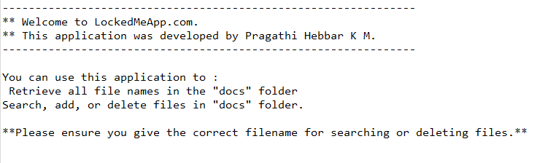

1. **Display Menu options available for the user**

1. **Display Secondary Menu for File Operations**

1. **Display user input in initial Menu (Retrieving files)**

1. **Search for a file**

1. **Creating “docs” folder in project if it’s not already present**

1. **Display all files in “docs” folder in ascending order**

1. **Create a file/folder as specified by user**

1. **Delete file specified by user input in “docs” folder**

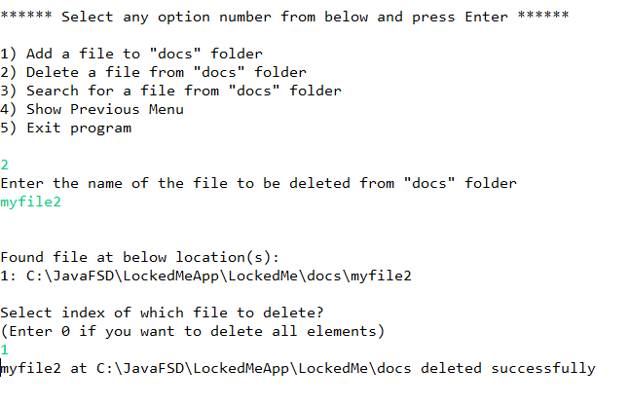

1. **Going back to main menu**

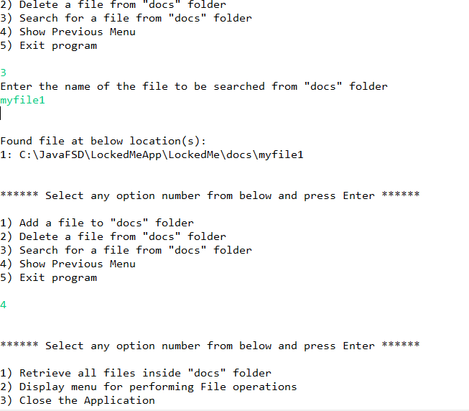

1. **Closing Application/Program**

